

National Technical University of Athens

School of Civil Engineering

Acad. Year: 2020-2021

**Course: Stochastic Finite Element methods**

4th Assignment

Consider the plane stress problem:

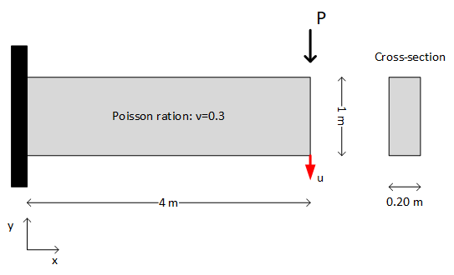

with $P=10kN$ and $E$ being a random variable, whose initial distribution (prior) is considered to be $N\left({10}^{5}, 2⋅{10}^{4}\right) (kN/m^{2})$. Suppose you have performed an experiment and measured the response $u$ to be $10cm$. Assume an additive error $ε$ for the model, which follows the Gaussian distribution with zero mean and standard deviation 1 (cm).

Perform Bayesian update using the Acceptance-Rejection sampling algorithm to find the posterior distribution of $E$.